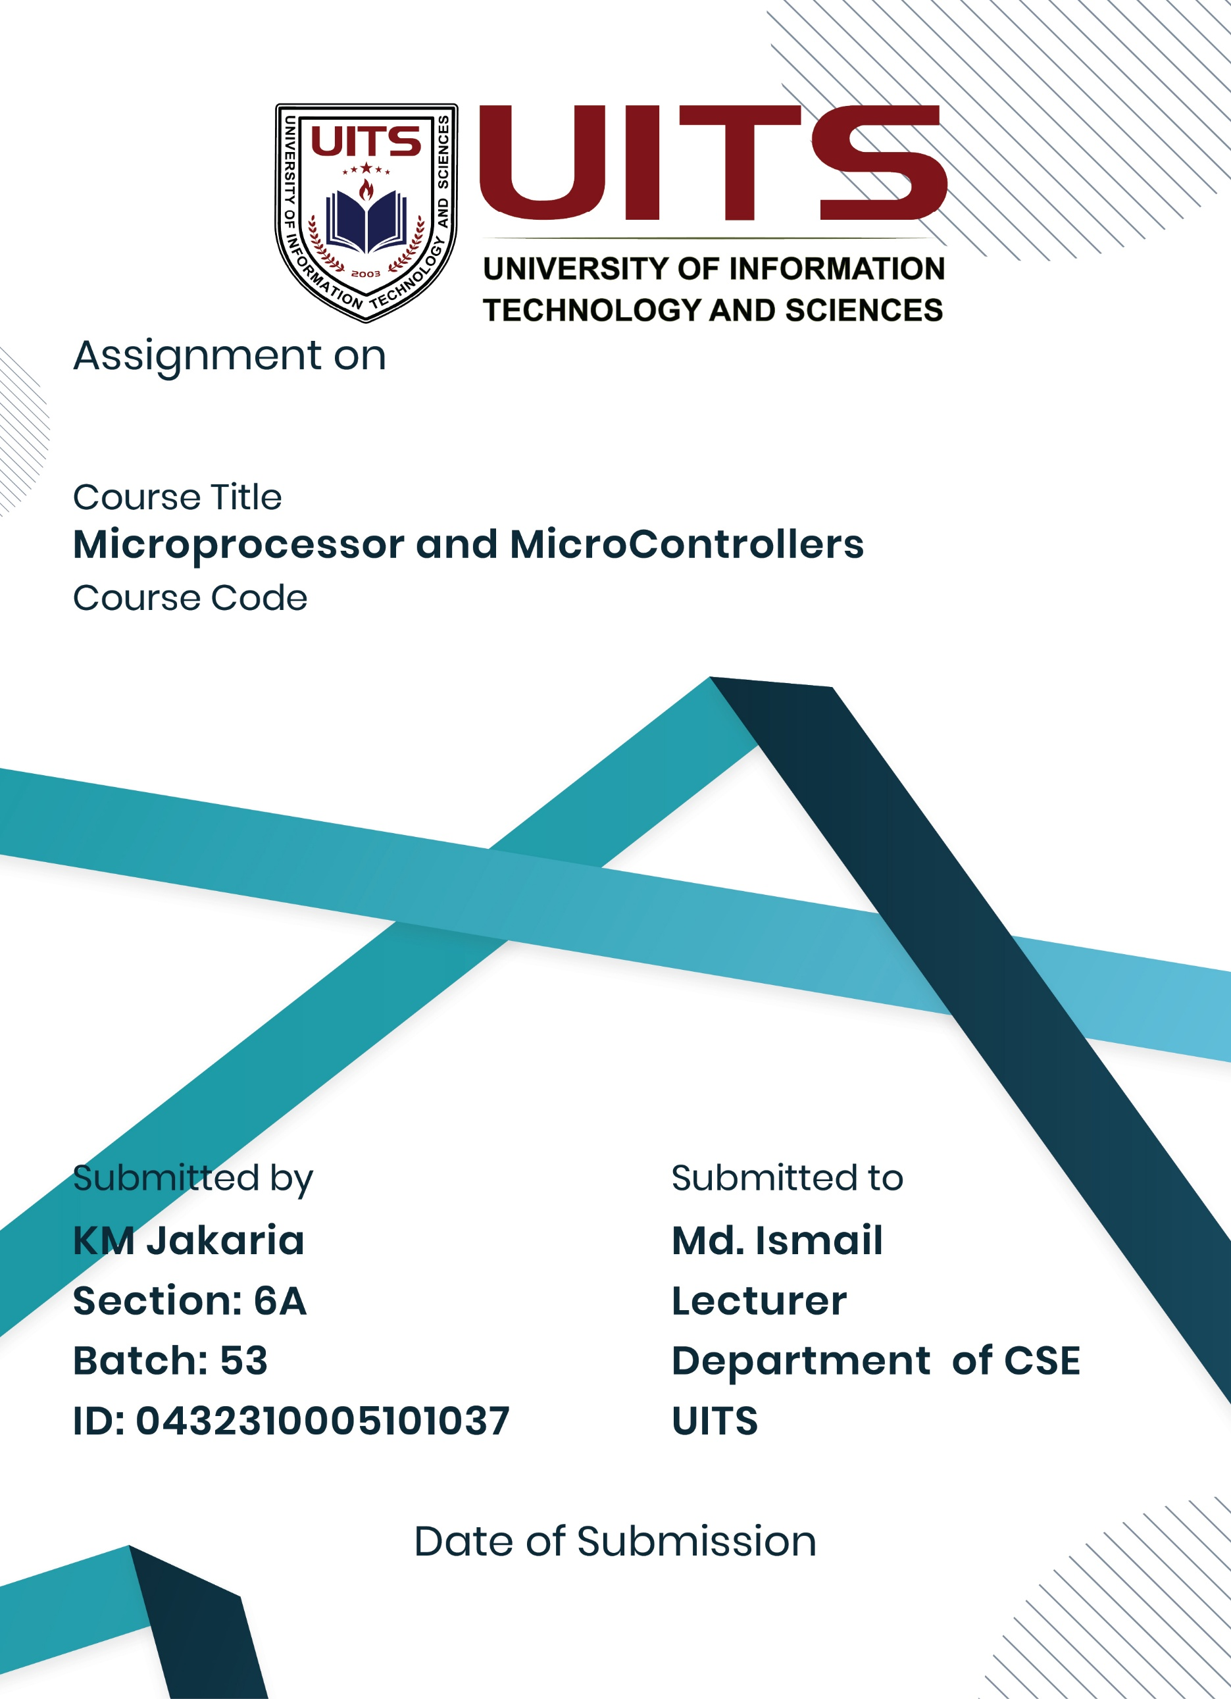
10 Nov, 2025
Lab Report- 06
CSE 360
Problem No: 06
Experiment No: 06
Experiment Name: Write an Assembly Language Program to Reverse a String.
Process:
Initialize registers to point to the start of the array. For the character array, use a loop (or direct offset) to access each character and load it into the appropriate register. For the string array, use a loop (or direct offsets) to load the address of each string into the register. Use int 21h function 09h to display each character or string on the screen.
Print a new line after each string (for the string array). Repeat the process until all
characters or all strings in the array have been displayed.
Implementation:
DATA SEGMENT
msg1 DB 'String: $'
msg2 DB 0DH,0AH,'Reversed String: $'
str1 DB 'JAKARIA$', 0
DATA ENDS

CODE SEGMENT
ASSUME CS:CODE, DS:DATA
START:
MOV AX, DATA
MOV DS, AX

LEA DX, msg1
MOV AH, 9
INT 21H

LEA DX, str1
MOV AH, 9
INT 21H

LEA SI, str1
MOV CX, 0

FIND_LEN:
MOV AL, [SI]
CMP AL, '$'
JE GOT_LEN
INC SI
INC CX
JMP FIND_LEN

GOT_LEN:
DEC SI
LEA DI, str1

MOV BX, CX
SHR BX, 1

REVERSE_LOOP:
MOV AL, [DI]
MOV DL, [SI]
MOV [DI], DL
MOV [SI], AL

INC DI
DEC SI
DEC BX
JNZ REVERSE_LOOP

LEA DX, msg2
MOV AH, 9
INT 21H

LEA DX, str1
MOV AH, 9
INT 21H

MOV AH, 4CH
INT 21H
CODE ENDS
END START
Result:
The application displays every character array element on the screen. Every string in the string array is printed on a separate line by the application.
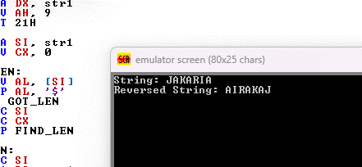

Conclusion:
The assembly language program to reverse a string was successfully implemented and executed. The program demonstrated pointer manipulation and character swapping in 8086 assembly.

